# JS Advanced - Retake Exam

Exam problems for the [“JavaScript Advanced” course @ SoftUni](https://softuni.bg/courses/javascript-advanced). Submit your solutions in the SoftUni Judge system at <https://judge.softuni.bg/Contests/TODO/>.

## Problem 4. Freelance Offers

Use the given **resources** to solve this problem. You have **NO permission** to directly change the given HTML code (index.html file).

### Your task

You have been tasked to create a simple Front-End application, which looks like a **freelance offers platform**. You should create an interface that allows the user to **login, create offers, archive offers** and **logout**.

The web page should look like this:

* When the user is **logged out**:

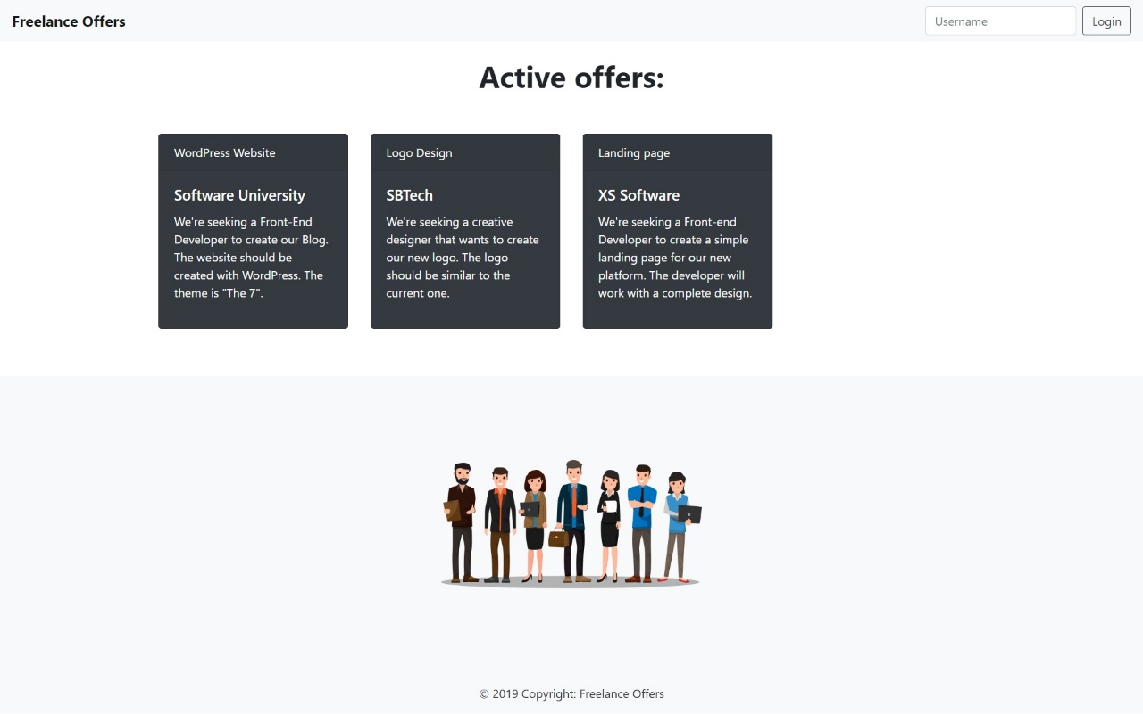

* When the user is **logged** **in**:

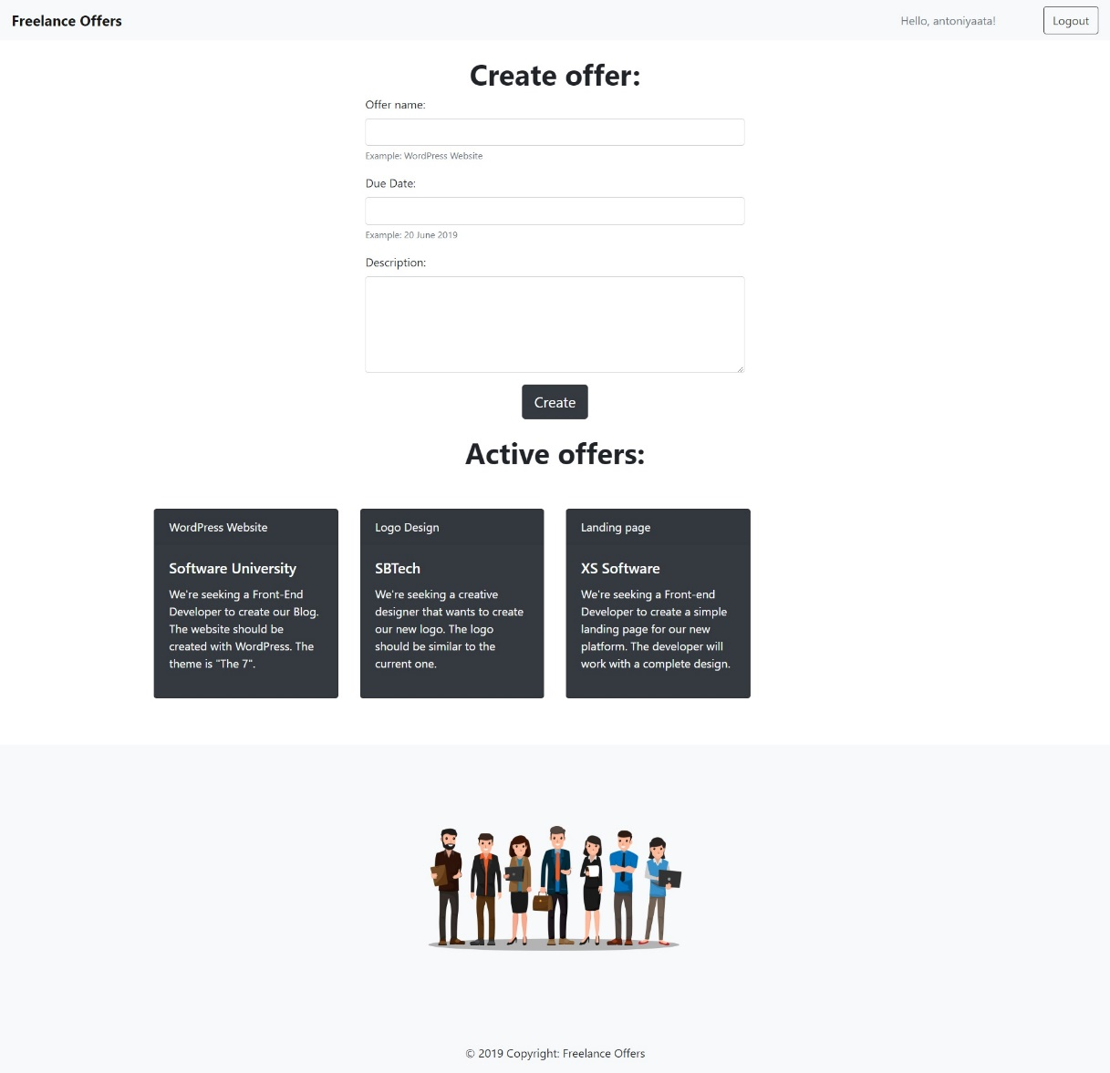

The application contains **4 main functionalities**:

* **Login**
* **Create** offers
* **Archive** offers
* **Logout**

#### Login

The application should provide functionality to **login** with **username**. The username should have the following **validations:**

* The username should **NOT** be an empty space.
* The username length should be **between 4 and 10** symbols.

When the user is successfully logged in the **form** **for** **creating** **offers** should be **visible**. Also the **username** should be displayed on the **input field** by following with "**Hello,** " and ends with "**!**" . To achieve the white background visual effect add "**border-0 bg-light**" **class** to the username field. The **button** **text** and **functionallity** should be changed to [Logout].



If the input username do **not match the validation** remind him from the **notification element.**



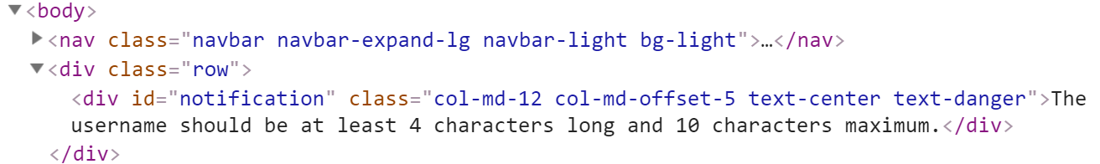

#### Create offers

The application should provide functionality to **create offers** for **logged users**. If the user is **logged in** he must be able to see the **form** for **creating** **offers**.

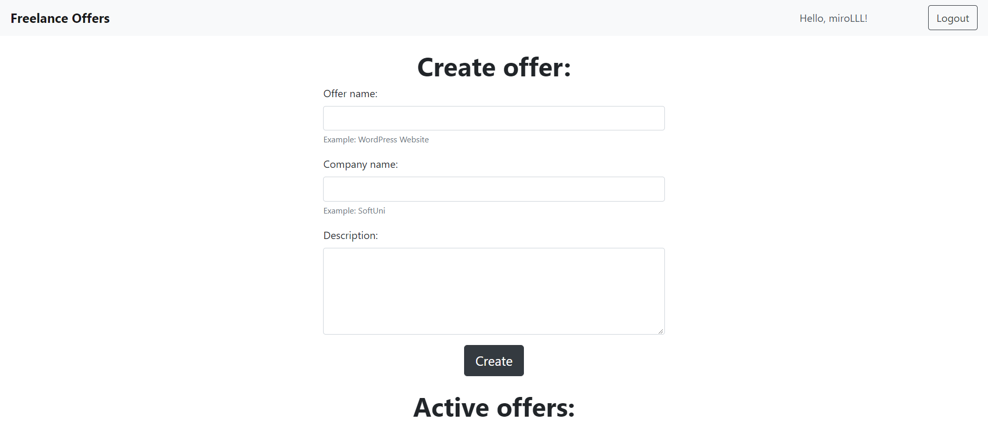

The form should have input fields for **offer name**, **due** **date** and offer **description**.

The Create offer form should has some **validations**:

* **Offer name** - Should be at least 4 characters and 10 characters maximum.
* **Company name** - Should be at least 2 characters and 10 characters maximum.
* **Description** - Should be at least 20 characters and 120 characters maximum.

When some offer being created successfully, the creator should see **[Archive] button** and the create offer form **fields should be cleared**. Note that only the creator on that offer can see the **Archive button**.

If some of the validations **do not match**, use notification element, when you start from the top to bottom and print only 1 error validation.

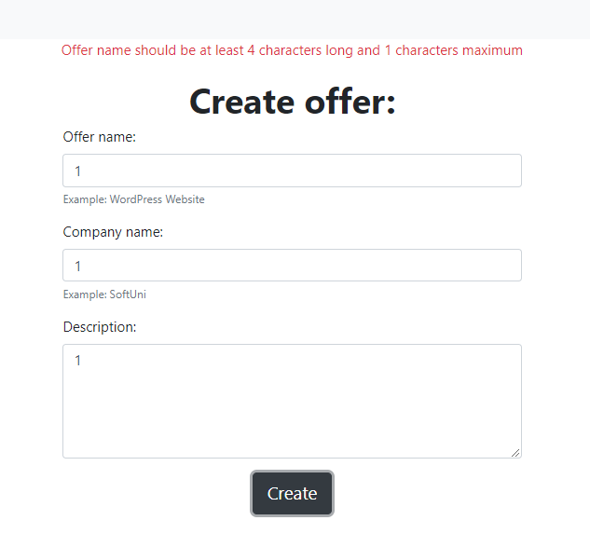

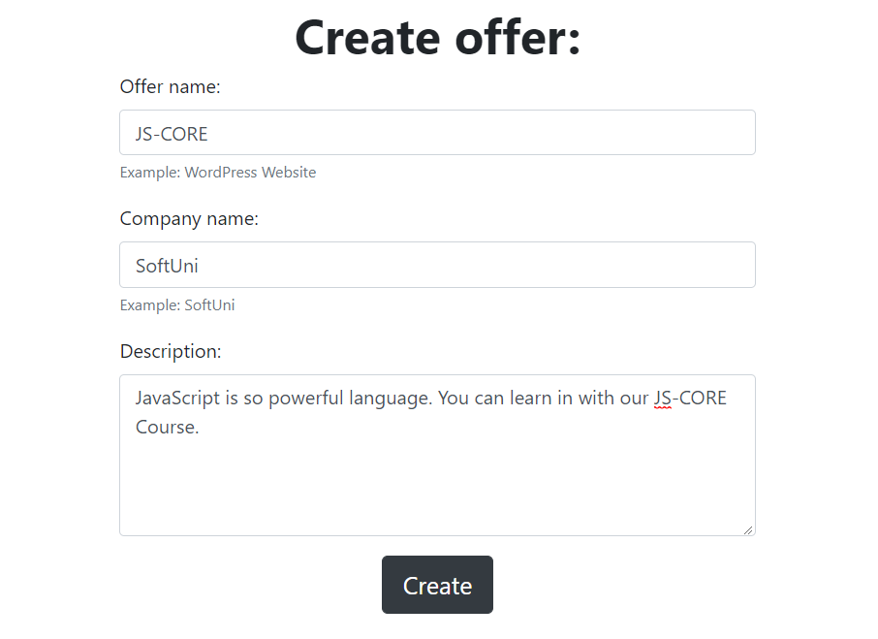

Here some example where only **1** of the offer **is ours**.

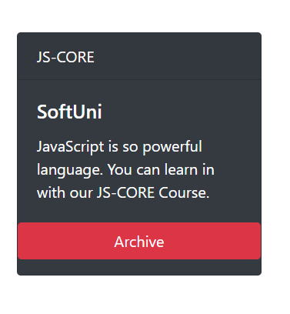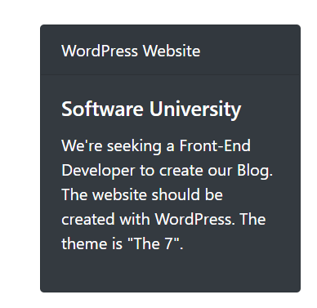

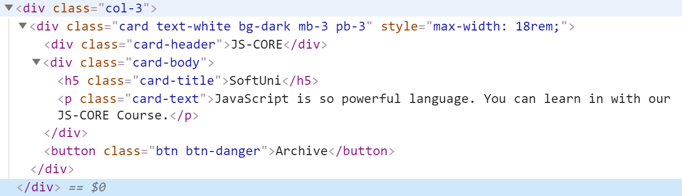

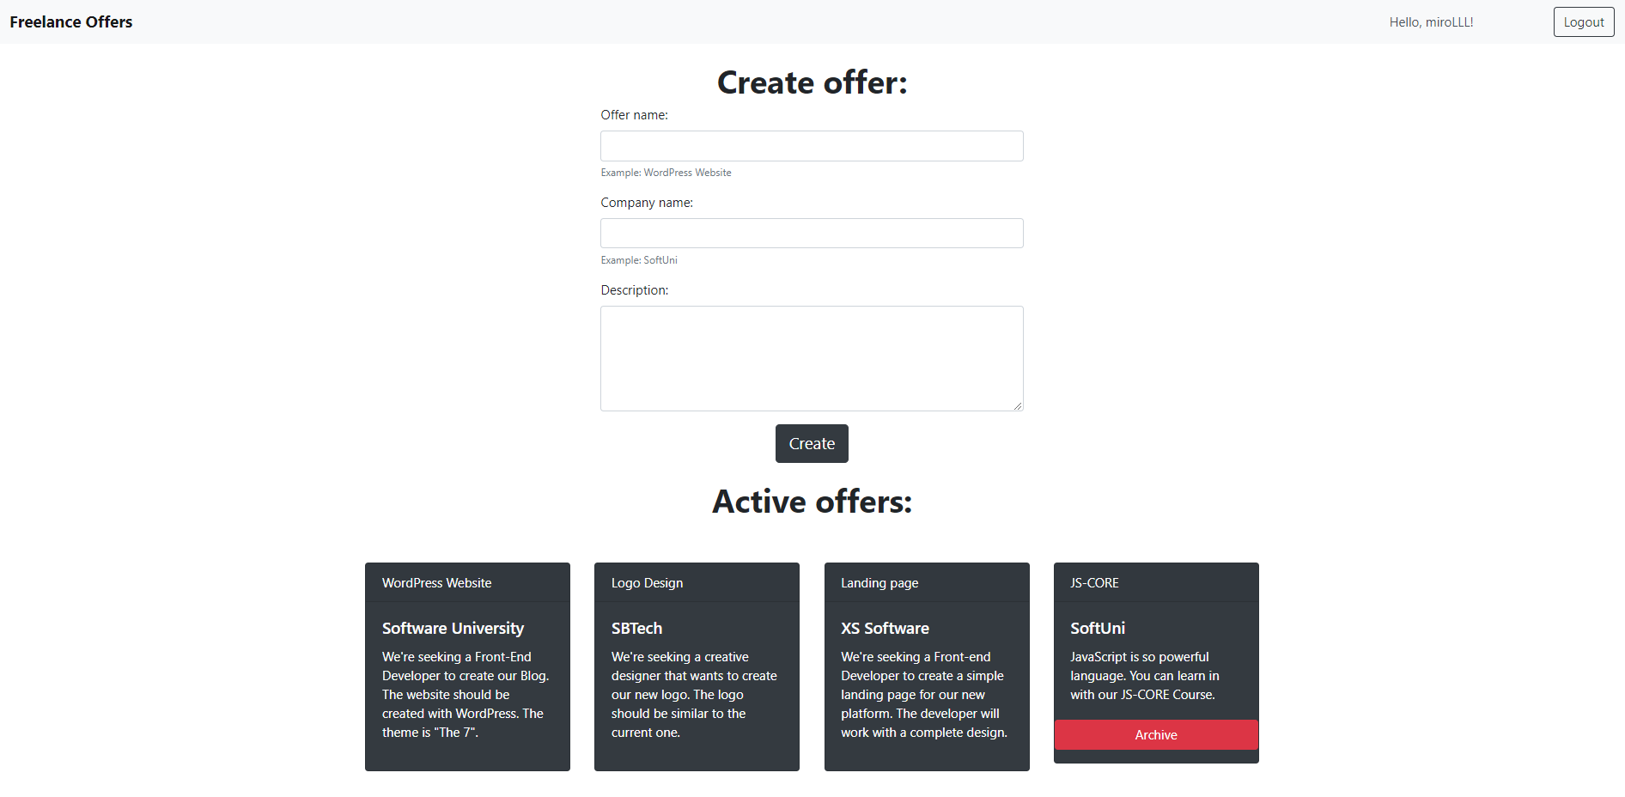

#### Archive offers

The application should provide functionality to **archive** the **created offers**.

If the user **click on** the **[**Archive**]** button's offer where he is the creator the offer should be **deleted** from the list.

#### Logout

The application should provide functionality to **logout**.

When user click the **[**Logout**]** button he should be able to see the **default page (Login functionality)** again.